# Overview of Dependency

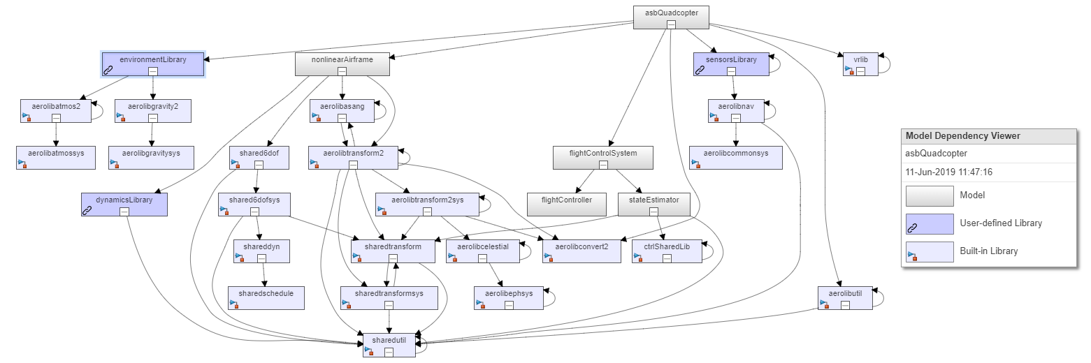

# Dependency from Aerospace Toolbox:

startVars.m - This script initializes variables and buses required for the model to work.

# Dependency from Signal Processing Toolbox:

EstimatorVars.m - This script determines the estimates of IMU, position, velocity, altitude

# Dependency from Aerospace Blockset:

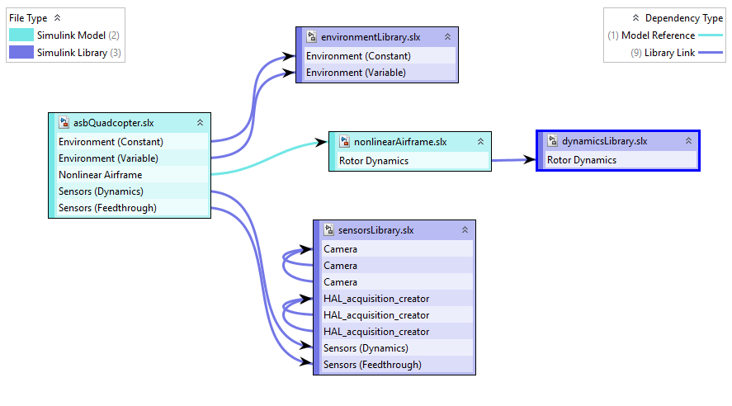

1. **Environment Block (variable environment) – uses the following models from aerospace blockset.** NOTE: Constant environment block not affected by aerospace blockset.

* **WGS84 gravity models** - Calculate Earth's gravity at a specific location using World Geodetic System (WGS 84).
* **COESA Atmosphere model** - Given geopotential altitude, calculate absolute temperature, pressure and density using standard interpolation formulas.
* **World Magnetic Model** - Calculate the Earth's magnetic field at a specific location and time using the World Magnetic Model (WMM). This model is valid for the year 2015 through the year 2020.

The WMM-2015 can be found on the web at: <http://www.ngdc.noaa.gov/geomag/WMM/DoDWMM.shtml>

1. **Sensor Block (dynamic) – uses the following models from aerospace blockset**

NOTE: Sensor Feedthrough block not affected by aerospace blockset.

* + **Three-axis Inertial Measurement Unit model**

1. **NonLinear Airframe Block – uses the following models from aerospace blockset**
   * **Dynamic Pressure (under Drag Calculation) -** Compute dynamic pressure using velocity and air density.
   * **6DOF (Quarternion) -** Integrate the six-degrees-of-freedom equations of motion in body axis.
   * **Flat Earth to LLA (under Position on Earth)-** Estimate geodetic latitude, longitude, and altitude from flat Earth position. The flat Earth coordinate system assumes the z-axis is positive downwards.
2. **Signal Builder (input) – the joystick model uses ‘’Pilot Joystick block’’ from aerospace blockset**